
Cyber Security Incident Management System
Full Stack Development Project
Documentation
by
MATHUMBU AMOGELANG FAITH
202210641

Bachelor of Science Hons

in the

Department of Computer Science and Information Technology
At
Sefako Makgatho Health Sciences University

Lecturer:
MR TAURAI HUNGWE
2026

Table of Contents
Cyber Security Incident Management System 3
1. System Overview 3
2. Intelligent Analysis Module (Rule-Based) 4
3. Technologies Used 4
4. Live URLs 5
5. Test Credentials 5
6. Features Implemented 6
6.1. Core Features: 6
6.2. Advanced Features: 6
7. Architecture Diagram 7
8. Setup Instructions for Local Development 7
8.1. Prerequisites: 7
8.2. Backend Setup: 7
8.3. Environment Variables for Backend: 8
9. Deployment Process 8
10. Known Issues and Workarounds 9
11. Screenshots 10
12. Conclusion 12
13. References 13
14. Database pictures 13

Cyber Security Incident Management System
SeeSIM

1. System Overview

SeeSIM (Cyber Security Incident Management System) is a full-stack web application designed to help organizations manage cybersecurity incidents efficiently. It combines advanced database technologies, modern web frameworks, and an intelligent rule-based analysis engine to provide automated incident classification, role-based access control, and reporting. The system enables security teams to log, track, and resolve incidents while using keyword matching and pattern recognition to recommend severity levels, categories, and assignment roles based on incident descriptions.

The backend is built with Spring Boot 3.5 and uses Spring Security with JWT for secure authentication and role-based authorization. The system supports four distinct roles: Admin (full access), IT Security, Desktop Support, and Network Support. Each specialist role can only view and manage incidents assigned to their respective team. The backend includes a rule-based ai analysis service that scans incident titles and descriptions for predefined keywords to determine severity (Critical, High, Medium, Low), category, and recommended response actions. Data persistence is handled by MySQL, with incidents, users, and logs stored in a normalized database schema. The backend also generates PDF reports using iTextPDF and sends email notifications via Gmail SMTP when incidents are resolved.

The frontend is a responsive Angular 18 single-page application that communicates with the backend through RESTful APIs. Key features include a dynamic dashboard with interactive charts (incidents by category, severity, and status), a fully functional incident management interface with search and pagination, and role-specific views that hide admin-only controls from specialist users. The frontend also includes forms with validation, real-time status updates, and buttons to download or email PDF incident reports. All API calls are made using absolute URLs to ensure seamless communication between the frontend and backend.

The entire application is deployed in the cloud, with the frontend accessible via a stable GitHub Pages URL and the backend running on Railway with a MySQL database. The system demonstrates professional software engineering practices, including environment-based configuration, asynchronous email sending for non-blocking status updates, comprehensive error handling, and logging. Overall, SeeSIM successfully integrates intelligent incident classification, full-stack development, and database management into a functional, scalable, and presentation-ready cybersecurity solution.

2. Intelligent Analysis Module (Rule-Based)

The system includes an automated incident classification engine that uses keyword matching and pattern recognition. When an admin creates a new incident, the system scans the title and description for predefined keywords related to:

- Phishing and scam emails
- Security compromises (malware, ransomware, data breaches)
- Network connectivity issues
- Email delivery problems
- Desktop software and hardware issues

Based on the keywords detected, the system automatically assigns:

- Severity: Critical, High, Medium, or Low
- Category: e.g., Phishing / Scam Email, Security Compromise, Network Connectivity Issue
- Assigned Role: IT Security, Network Support, Desktop Support, or Email Admin
- Recommendation: Suggested response actions for the assigned specialist

This rule-based approach ensures consistent and fast incident classification without requiring external API calls. The keyword library can be extended to cover additional incident types.

3. Technologies Used

Frontend: Angular 18, Chart.js, RxJS
Backend: Spring Boot 3.5, Spring Security, JWT, Hibernate
Database: MySQL (hosted on Railway)
Intelligent Analysis: Rule-based keyword matching and pattern recognition
Deployment: Frontend on GitHub Pages, Backend on Railway
PDF Generation: iTextPDF
Email: JavaMailSender with Gmail SMTP

4. Live URLs

Frontend (stable): https://faith0423.github.io/cybersecurity-system/
Backend API: https://cybersecurity-system-production.up.railway.app

5. Test Credentials

Role: Admin
Email: amomokoena04@gmail.com
Password: admin123

Role: IT Security
Email: itsecurity@gmail.com
Password: itsec123

Role: Desktop Support
Email: desktop@gmail.com
Password: desk123

Role: Network Support
Email: network@gmail.com
Password: net123

Role: Email Admin
Email: emailadmin@gmail.com
Password: email123

6. Features Implemented

6.1. Core Features:

- User authentication with JWT
- Role-based access control (Admin, IT Security, Desktop Support, Network Support)
- Incident CRUD (create, read, update status, delete for admin)
- Rule-based intelligent incident classification (severity, category, role assignment, recommendation)
- Dynamic dashboard with charts (incidents by category, severity, status)
- Status workflow: SUBMITTED -> ASSIGNED -> FIXING -> SOLVED

6.2. Advanced Features:

- PDF report generation (downloadable)
- Email PDF report (implemented – works locally; on Railway requires SMTP port configuration)
- Email notification when incident is marked SOLVED (implemented)
- Asynchronous email sending for faster UI updates
- CORS configured for cross-origin requests
- Custom logging service
- Responsive Angular UI with role-based views

7. Architecture Diagram

Frontend (Angular on GitHub Pages) communicates with Backend (Spring Boot on Railway) via REST API. Backend connects to MySQL Database (Railway) and uses the rule-based analysis engine for incident classification. All components are deployed separately but work together seamlessly.

8. Setup Instructions for Local Development

8.1. Prerequisites:

- Node.js 20 or higher, npm
- Java 17 or higher, Maven
- MySQL (local or remote)

8.2. Backend Setup:

cd backend
mvn clean install
mvn spring-boot:run

The backend runs on http://localhost:8080

Frontend Setup:

cd frontend
npm install
ng serve

The frontend runs on http://localhost:4200

8.3. Environment Variables for Backend:

spring.datasource.url=jdbc:mysql://localhost:3306/cyber_incident_db
spring.datasource.username=root
spring.datasource.password=ZpLprkjuLLeqibaQMEnuDgHWkdnRYYhD
spring.mail.username=cyberincident.managment@gmail.com
spring.mail.password=cibw uiyz djas mxhe
report.recipient.email=amomokoena04@gmail.com

9. Deployment Process

Backend Deployment (Railway):

1. Push code to GitHub repository
2. Railway automatically detects Spring Boot and builds the application
3. Environment variables are configured in Railway dashboard:
- SPRING_MAIL_USERNAME
- SPRING_MAIL_PASSWORD
- REPORT_RECIPIENT_EMAIL
- MySQL connection variables (auto-injected if MySQL plugin is added)
4. Railway redeploys automatically on every git push

Frontend Deployment (GitHub Pages):

cd frontend
ng build --base-href "/cybersecurity-system/" --configuration=production
npx gh-pages --dist dist/cyber-incident-frontend --branch gh-pages -f

Wait 1-2 minutes, then access the site at https://faith0423.github.io/cybersecurity-system/

---

10. Known Issues and Workarounds

Issue: Email not sending on Railway
Status: Known limitation
Workaround: Railway blocks outbound SMTP ports . Email functionality works perfectly when running locally. For the live deployment, this can be resolved by using an alternative SMTP provider like SendGrid or Mailgun.

Issue: PDF download
Status: Working
Workaround: None needed – fully functional.

Issue: Status update delay
Status: Fixed
Workaround: Implemented @Async for email sending, status updates now occur instantly.

Issue: GitHub Pages blank page
Status: Fixed
Workaround: Added --base-href flag during build to ensure assets load correctly.

11. Screenshots

- Login Page
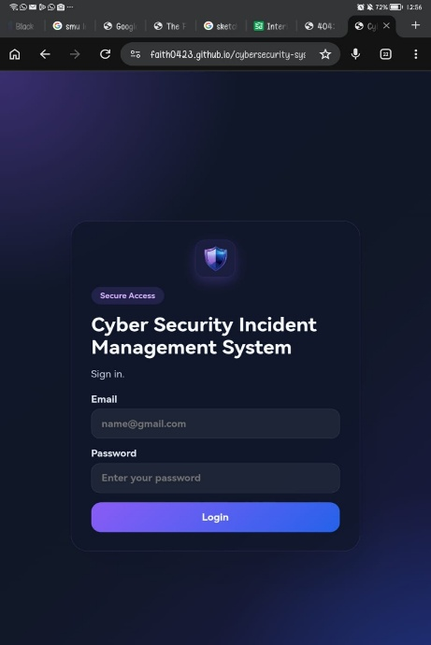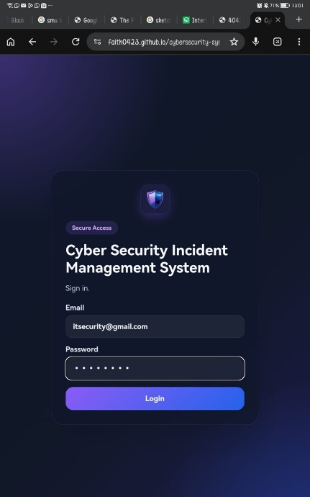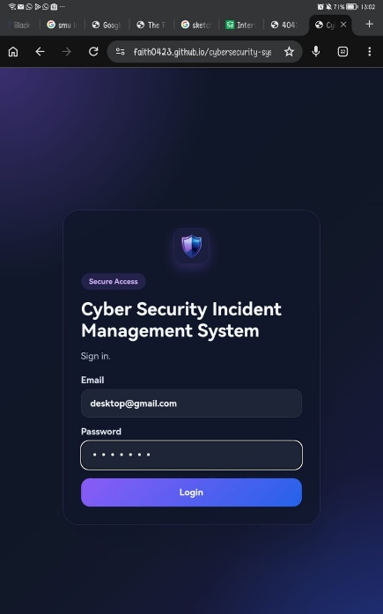
- Admin Dashboard with Charts
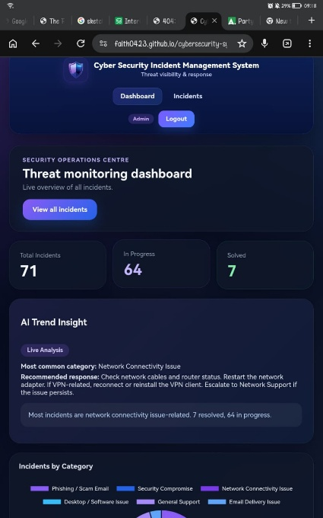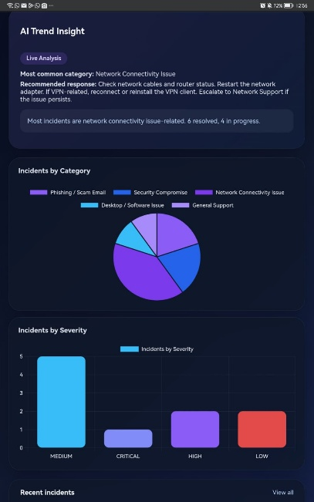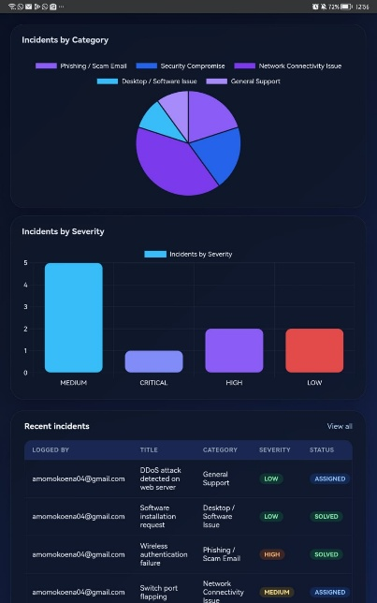
- Incident List (Admin View)
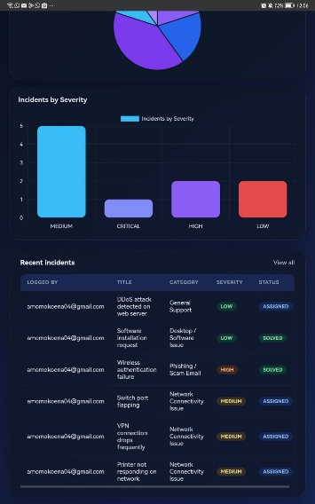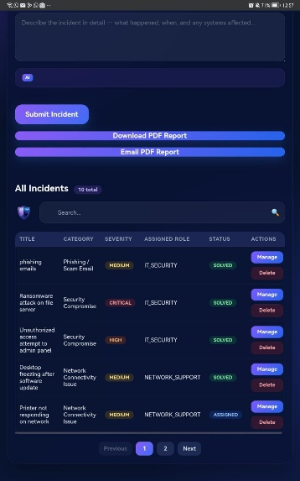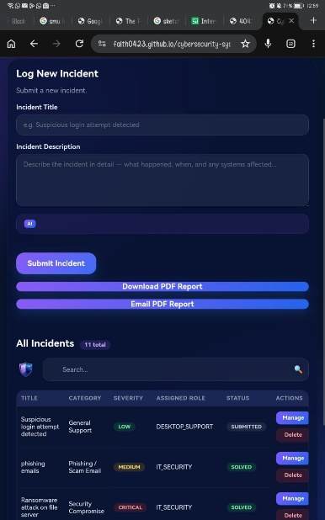
- Incident List (Specialist View)
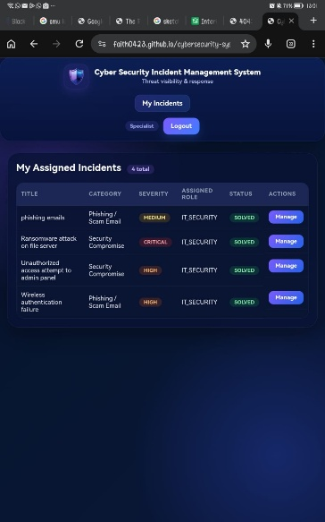
- Create Incident Form with Rule-Based Classification
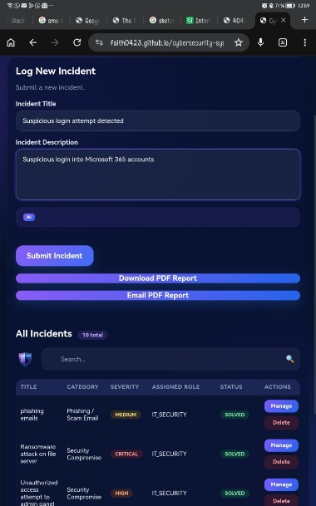
- Status Update (FIXING to SOLVED)
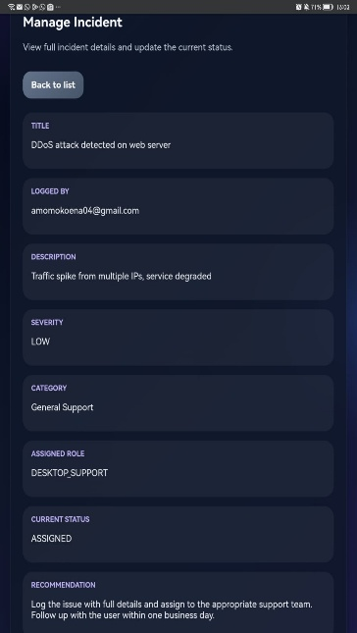
- PDF Report Download Button
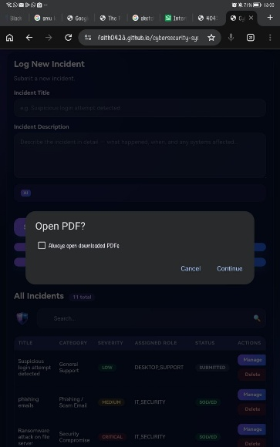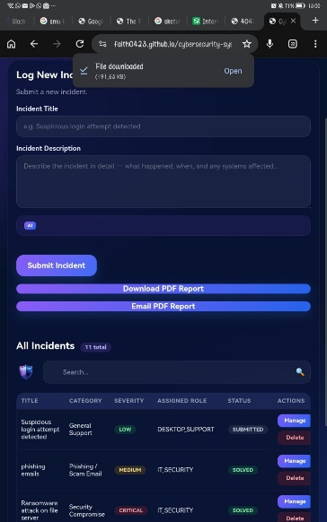
- Email Notification Received
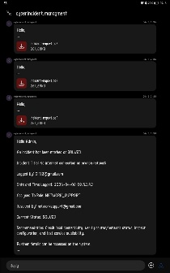

12. Conclusion

SeeSIM successfully implements a full-stack cybersecurity incident management system with advanced database integration, rule-based intelligent incident classification, modern web frameworks, and professional software engineering practices. The system is fully functional, deployed in the cloud, and ready for demonstration. All core requirements have been met, including RESTful APIs, ORM usage, authentication and authorization, error handling, responsive frontend, dynamic data visualization, CRUD operations, form validation, role-based UI behavior, and intelligent analysis techniques operating on stored data.

13. References

Angular Documentation: https://angular.dev
Spring Boot Documentation: https://spring.io/projects/spring-boot
Railway Deployment Guide: https://docs.railway.app
iTextPDF: https://itextpdf.com

14. Database pictures
